1. Deploy your your previous assignment flask frontend and express backend in kubernetes cluster locally with minikube.
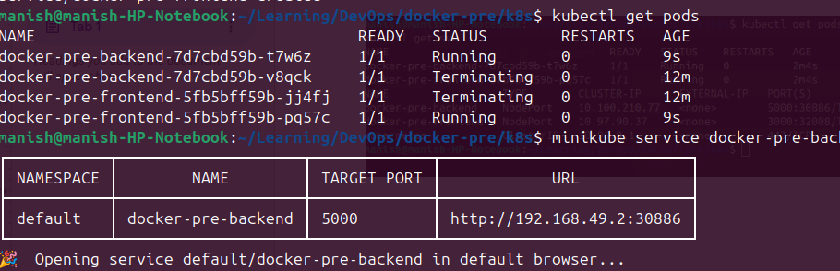

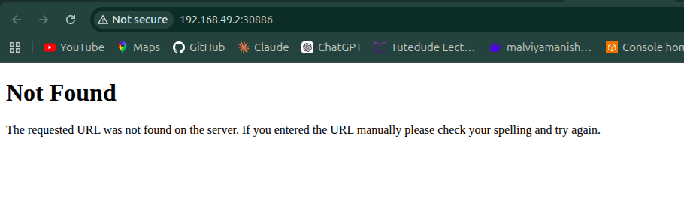
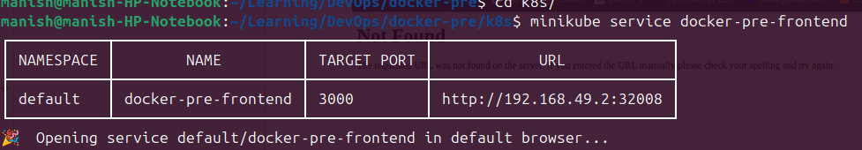
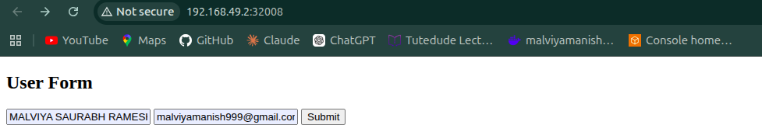

Technologies Used
- Docker
- Kubernetes
- Minikube
- kubectl
- Flask
- Express.js

Commands Used

Start Minikube
minikube start

Apply Kubernetes Files
kubectl apply -f backend-deployment.yaml
kubectl apply -f backend-service.yaml
kubectl apply -f frontend-deployment.yaml
kubectl apply -f frontend-service.yaml

Verify Pods
kubectl get pods

Verify Services
kubectl get services

Screenshots Included
- Running Pods
- Running Services
- Running Deployments
- Frontend Output
- Backend Output

